How to run ProWorkJS

1. Put the whole ProWorkJS package in C:

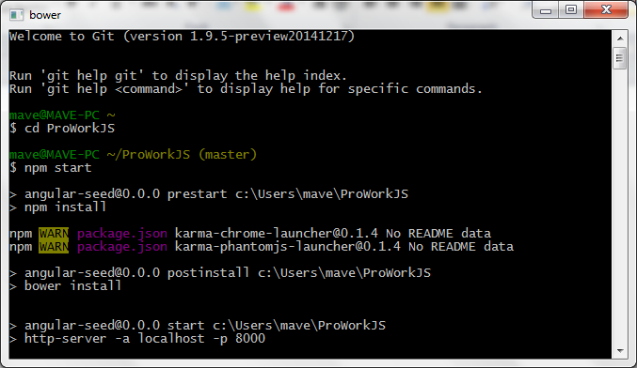

2. See the following:

Not bower.json file, failed! copy&paste it , then can run propertly

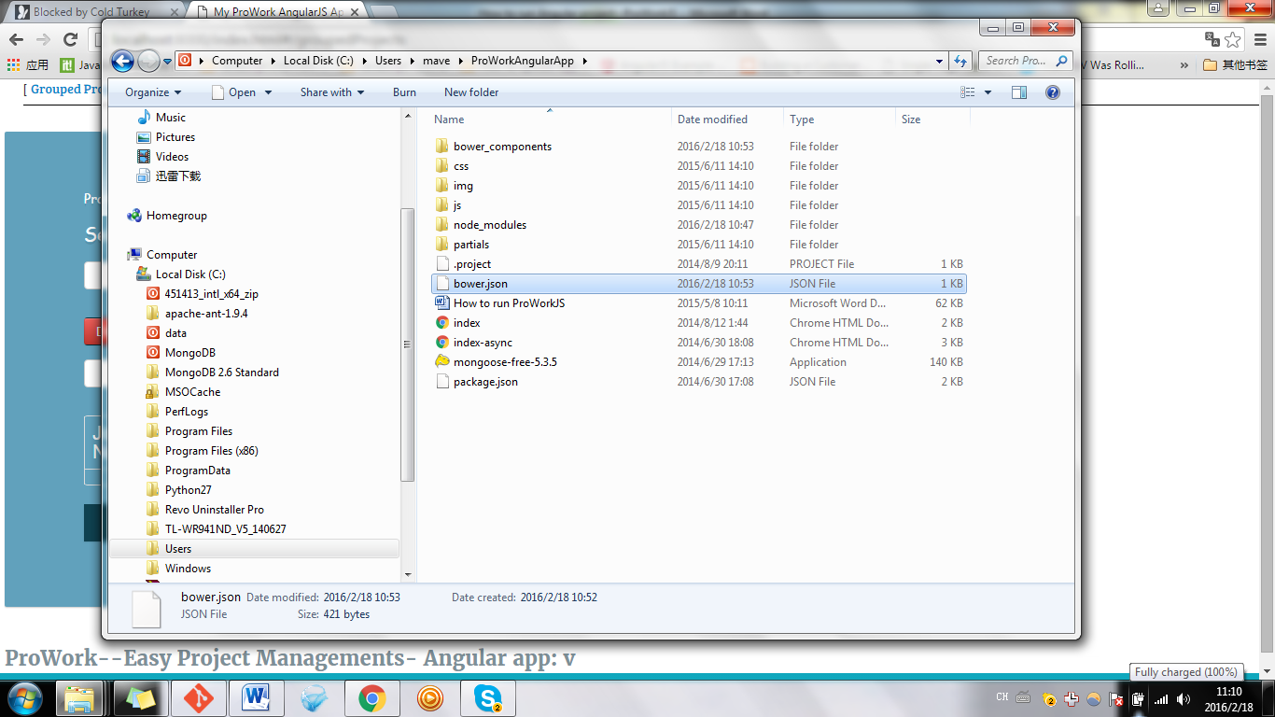

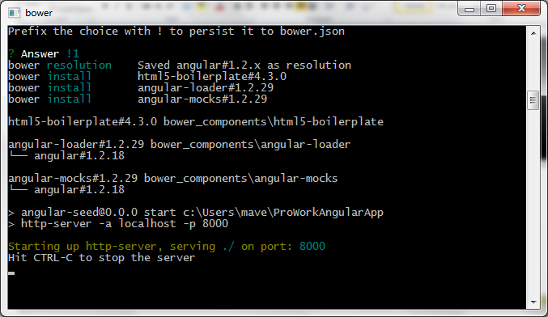

3: type: <http://localhost:8000>, press Enter, see the following

